**Task20 – Console Result Screenshot**

**Question 1: Date Picker**

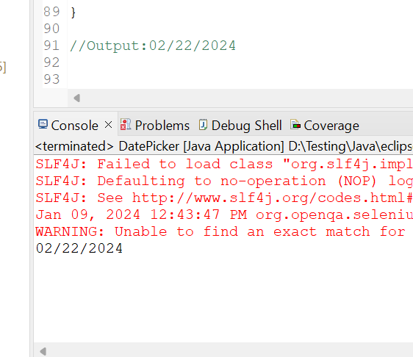

**Question 2: Guvi Portal**

